**By: Vatsal Shah**

**(130280107123)**

**Business Model Canvas Report**

**Business Canvas Model:**

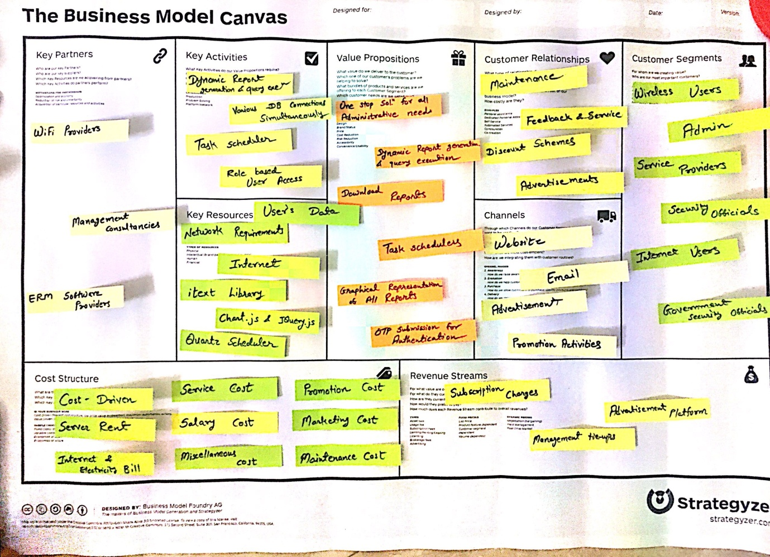

* **KEY PARTNERS:**
* **WiFi Providers:**

Such partners would always avail this opportunity to get maximum out of the system. They will use and buy this system as they will get easy and convenient administrator portal.

* **Management Consultancies:**

The Management committee includes the main management makers regarding our application. The application will help them in making decisions, costing, auditing and forecasting about trends.

* **ERM software providers:**

ERM software Providers are the firm who are more entangled to provide sophisticated software to client to make their Entity Relationship stronger.

* **KEY ACTIVITIES:**
* **Dynamic Report Generation & Query Execution:**

In Operation and Maintenance utility system, to reduce the redundant task in some unified predefined schema, the application provides Dynamic report generation system and the system will allow administration to execute each valid query to their data.

* **Simultaneously Various database connection:**

We have specially worked to achieve the functionality in our application that simultaneously support every possible Database server with the application a and execute given task on any given Database connection.

* **Task Scheduler:**

In Operation and Maintenance utility system, to give more flexibility and advancement to carry out different task at their given specific time, Task scheduler will help them in carrying out and executing them perfectly.

* **Role Based Application Access:**

We have made a application system in such a way that all the options available to the user will only contain specific functions only which are allocated to them due to their role based Application access.

* **KEY RESOURCES:**
* **Users’ data:**

Our main resource is data set that is generated through our day to day audit of the internet accessed customers and administration side staff. The Data generated from day to day entry will also help in improving further enhancement decision making for the application.

* **Network requirements:**

We need server access and domain registration for this purpose.

* **SMS Gateway API:**

It is used for generating OTP for authentication and much more functionalities. We can use it for more than one ways.

* **Chart.js:**

It is for showing graphs in an intuitive graphical way. We can add various styles to the graphs.

* **JQuery.js:**

It is for making data interaction more powerful and efficient with User Interface and Backend both.

* **iText Library:**

It is for making web paged portrayed data to convert in storable mode like PDF format.

* **VALUE PROPOSITIONS:**
* **One stop solution for all administrative needs:**

Our website provides complete administration needed guidance to the users.

* **Extensibility:**

Extensibility is a software engineering and systems design principle where the implementation takes future growth into consideration. The term extensibility can also be seen as a systemic measure of the ability to extend a system and the level of effort required to implement the extension.

* **Reliability:**

The ability of an apparatus, machine, or system to consistently perform its intended or required function or mission, on demand and without degradation or failure.

* **Flexible:**

Our system is able to be easily modified to respond to altered circumstances.

* **Accurate:**

Our system is able to give an accurate result.

* **Scalable:**

Scalability is the capability of a system, network, or process to handle a growing amount of work, or its potential to be enlarged in order to accommodate that growth.

* **CUSTOMER RELATIONSHIPS:**
* **Feedback (Reviews):**

Feedback will be a way for the user to provide his/her view of the website. The user can also rate our website from different angles so that the management of our website can figure out fields for improvement. Users can also give their good/bad reviews on our portal.

* **Maintenance:**

Maintenance helps customers with specific technical problems or improvements. The website must be maintained keeping in mind the preservation of regular customers and the attraction of new/potential ones.

* **Discount schemes:**

We will provide different types of discount schemes for loyal customers or to the customers who want to stay with us for a long period.

* **Advertisements:**

Advertisements are a major mode of communication between any company and the company’s current or future customer base. Advertisements are distributed among social media, internet, television, newspapers, radio stations and magazines to reach a wide population. They attract viewers towards using the company’s certain product or feature.

* **CHANNELS:**
* **Website:**

We want to spread our product to the more customers and users using its main platform that is website. The more people use website, the more product becomes famous among people.

* **Email:**

Through Email subscription we can reach the wide number of users and increase our active users.

* **Promotion Activities:**

Promotion activities have become a hit in today’s world for propagating the use of a certain products. What users and customers need in today’s busy world is a small boost towards purchasing/using a product. This boost may be in the form of a discount for new users, some sale, and added features for a specific time periods, etc. These activities promote the use of the product, thus the name.

* **CUSTOMER SEGMENTS:**
* **Admin:**

Site administrators can perform administrative functions such as modifying site pages, adding events, and customizing the contact database. Administrator can log in and access the admin backend – an area reserved for site and account administration, and not seen by ordinary members or visitors to your site.

* **Wireless Users:**

Wireless user will avail the opportunity to access internet via simple authentication steps of the application system.

* **Cardiac patients:**

They are our most targeted customers because our project currently predicts cardiovascular fitness only so they can take benefit from our project.

* **Service Providers:**

Our system is a website as it will help different service providers to join and make partnership and buy this application for their users.

* **Internet Users:**

Over 75% of the population uses the internet today. With so many user of the internet, there surely is a good proportion of that percentage who has the habit of goggling certain words, phrases or concepts to get a useful result. Our website will be highly used by such people.

* **Govt. Health Officials:**

We can also do tie ups with government health officials in order to improve public information and technology sector.

* **COST STRUCTURE:**
* **Cost Driven:**

Our business model is cost driven because it is costing the value to the client’s requirement and we make it by ourselves and to deliver this project to one of the customers.

* **Service Cost:**

The costs associated with helping customers and providing them with compensation in case of a fault of the company.

* **Server Cost:**

There is cost of server rent and domain booking cost for the website to be put on internet.

* **Salary Cost:**

We have to pay for the outside help that we took into our project.

* **Maintenance Cost:**

Cost of the website’s maintenance and maintenance of the machines, devices and other operational functionalities.

* **Marketing Cost:**

Advertising and marketing costs to be paid to advertising agencies, websites, apps, newspapers, television or play-stores.

* **Internet and Electricity Bill:**

The cost of network facilities and high-speed internet varies according to the usage of the company. The electricity costs of our company would be high due to heavy computer work and heavy use of electronic devices and main-streamservers.

* **Miscellaneous Costs:**

Other costs such as accidental damage, damage done by viruses, power failure, damage of components, etc.

* **REVENUE STREAMS:**
* **Subscription charges:**

We will charge our customers on the monthly/yearly basis for use of our website.

* **Advertisement platform:**

We can use our website and android application as an advertisement platform for other companies and can earn income from that.

* **Management tie-ups:**

We can earn money from the management tie-ups so that management companies can provide customized managemenet schemes to its users.